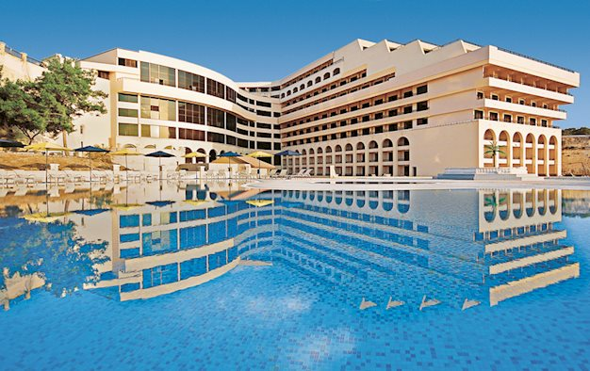

The base hotel for the Pilgrimage is the GRAND HOTEL EXCELSIOR in VALLETTA, MALTA
- See https://www.excelsior.com.mt/
The Hotel has provided preferential rates for those attending the activities. Please book your accommodation needs directly with hotel.
- Quote Promotional Code: MHOSLJ2024 for preferential rates

