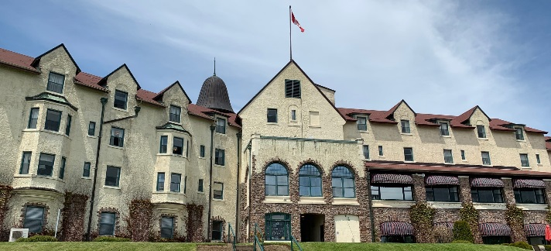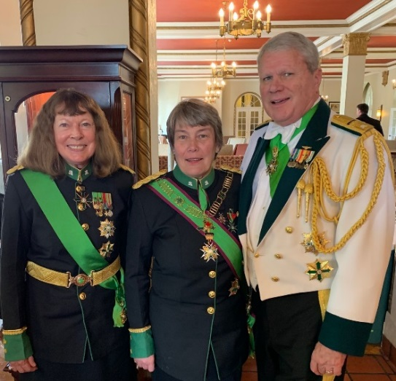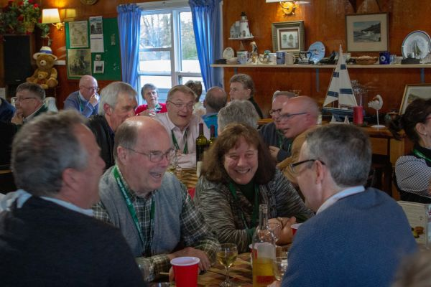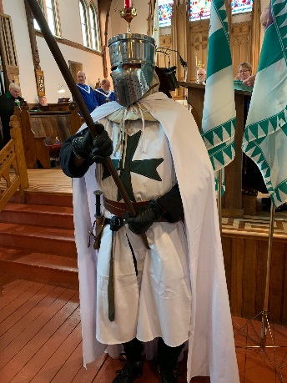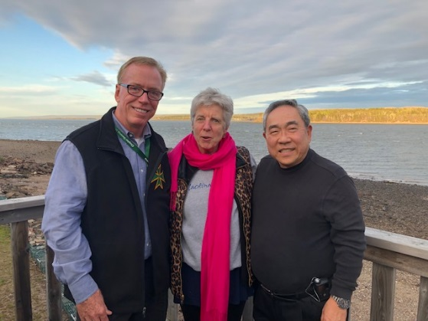Canadian Chapter General 2019

**John Byrnes, Lisa Kory, and Grand Prior Ken Moritsugu enjoy Digby Pines Resort and surrounding area.**

**The Gillulys join Jane Anema, newly invested Grand Prior of Canada.**

**A Kitchen Party includes lobster for all.**

**Could this be a new tradition?**

The Canadian Chapter General was held in Digby, Nova Scotia, May 23-26, 2019. Digby, located on the Bay of Fundy, boasts idyllic countryside and the best scallops in the world. Those on hand from the Grand Priory of America were Grand Prior Kenneth Moritsugu with Lisa, Grand Chancellor Marny Gilluly, Grand Marshal C.W. Gilluly, Grand Justiciar Hugh Straub with Mary Ann, and GPA Chancellor John Byrnes with Anna.

The Chapter General is the U.S. equivalent of our Grand Prioral Council meeting. This year Jane Anema, DCLJ, became Grand Prior of the Grand Priory in Canada, succeeding The Honorable Peter Milliken. Both Jane and Peter have been familiar faces at GPA events. Vigil and Investiture ceremonies welcomed new members, awarded and promoted current members, and were followed by wonderful social activities. The buzz throughout the meeting was from those who had just returned from the GPA Pilgrimage to the Holy Land, giving kudos to every aspect of the trip.

As part of the Chapter General business meetings, the Canadians initiated educational workshops dealing with hospice program startups, practical ecumenism, commandery best practices, and historical foundations of our Order. Canadian primary charitable efforts focus on palliative care and scholarships for post-secondary religious studies. The Order in Canada has donated over 2 million dollars to hospice facilities and has published *A Caregiver’s Guide*, a free handbook dealing with end-of-life issues.

Camaraderie, collegiality and collaboration between the Grand Priory of America and the Grand Priory in Canada continue to be alive and well, signs of our flourishing Order in North America.